- Introduction
Facing the risks requires that the company manages them, understanding in advance their nature and impact, monitoring the relevant indicators to anticipate their occurrence, and being ready to act immediately at the first signs of trouble. “Just as the physical, chemical, and biological processes that contribute to risk can be
studied scientifically, so can the processes affecting risk perceptions” (SLOVIC, 2000, p.6). The innovation leadership should include managing risks as a core competence. Without so, any innovation project can become an opportunity to dramatically fail the company’s objectives and sustainability.
This paper presents an research in process aimed at deepening scientific knowledge of managing the risks associated with personal values in crowdsourcing innovation In section 2, the literature review strategy are presented. The risk management and personal values are presented at section 3.

- Methodology
The interpretative viewpoint follows from the allowance for social intervention into the research setting. Our research appears to a qualitative approach (maybe an action research ) aimed at deepening scientific knowledge of build the theoretical framework to possibility an enhanced understanding of this complex social-organizational problem related with risk taken and personal values. The intention of the research is to answer the key question of: “What are the behavioral factors that affects risk perception? What human aspects should be considered?

- Literature Review Strategy

At first we have to focus on research work that explicitly use the terms risk management, personal values, risk management and personal values in the title, abstract, topics or keywords. We have restricted our search to the social sciences. Also we have not included industry reports or editorial material.
First, we perform an in-depth review of Risk Management (RM) papers published in quoted scientific journals and searched the two major databases of management journals and an additional management journal not covered by the databases: ISI Web of Knowledge database (Social Sciences Citation Index-SSCI) and Scopus Database. We have performed an exhausteive review of the scientific papers published in quoted journals since 2000. Thus, we looked in SSCI and Scopus for any paper containing these expressions in SSCI database, in title, abstract, topic or keywords. There weren´t any records for the keywords “risk management and personal values”.
After, we done a search for books with “risk management and personal values” in the title was made on the site of Amazon.com to identify books published in the field. We found 17 books and all books are included in the literature overview.
The current method shows us a comprehensive analysis of the journal articles published in the databases in the specified time period and about their content. Papers in trade journals and in journals that only refer to original papers were removed. Editorial material was also removed. Book reviews have been listed but are not included in the literature analysis.

- Risk Management Background

Risk can be understood as a set of vulnerabilities that affect the goals of an organization and have impact on its ability to achieve them. The risk can define a threat or an opportunity. In this context, risk has not only negative meaning; not taking advantage of opportunities can be considered a risk as well.
Therefore, risk may have a positive or negative impact on goals definition and the ability to achieve them. An organization is subject to risks that are identifiable within its strategic and operational context.
Once identified, such risks are assessed, measured and monitored in order to control, mitigate and eliminate its effects. Management model elements can include strategic planning, decision making, and other strategies, processes and practices for dealing with the risks.
The concept of risk expressed by Darlington et al (2001) can be adopted in this paper: “Risk is the threat that an event or action will adversely affect an organization ability to maximize stakeholder value and achieve its business objectives and business strategy. Risk arises as much from opportunities as it does from possible threats”, corroborating with this concept, risk is defined on AS/NZS 4360 Standards- 1999:2004 (AUSTRALIAN/NEW ZEALAND, 2004) as “the chance of something happening that will have an impact upon objectives and it is measured in terms of consequences and likelihood of an incident happening”.
The application of a risk management approach should be done in any situation where there is possibility of loss, or opportunities, at the strategic or operational level (AUSTRALIAN/NEW ZEALAND, 2004).
Renn (1998) define risk as the possibility that human actions or events lead to consequences that have an impact on what human’s value. This definition implies, accord him, that humans can and will make causal connections between actions (or events). They can be altered either by modifying the initiating activity or event or by mitigating the impacts. The Figure 1 adopted from Renn (1998) provides different concepts and perspectives of risk.

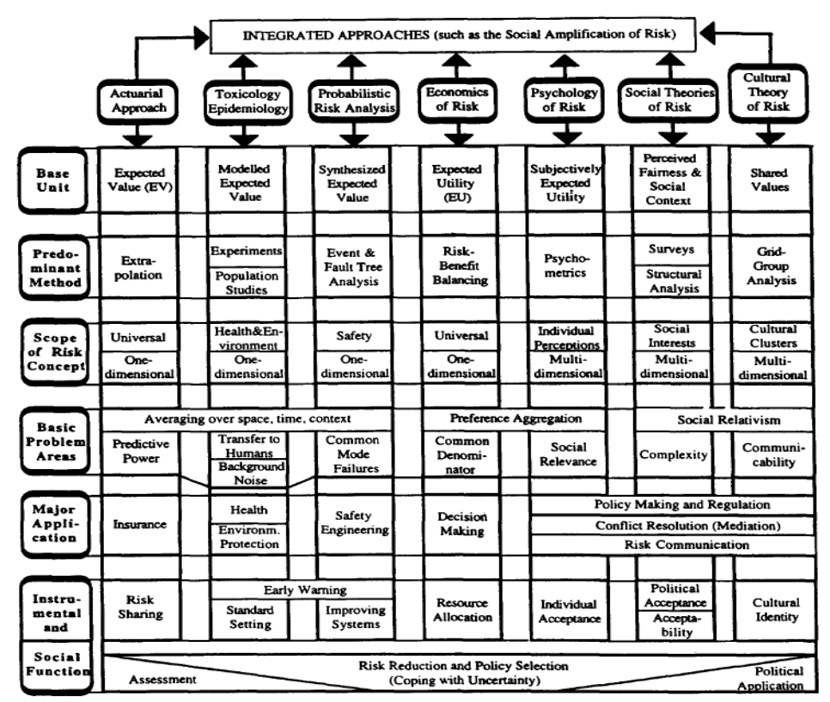
Figure 1Risk Perspectives
Source: Reen, 1998
Furthermore, it is important for risk management professionals to understand the difference between perceived risk and actual risk. Some studies have been carried out which provide some insights into the factors affecting perceptions of risk. Judgment plays a central role in decision-making, particularly when making complex strategic decisions.

- Risk Management and Personal Values

The personal values understanding are essential because they include the beliefs that the individual has on a subject, a course of action or the desirability of a future situation. The personal values are responsible for most of the unconscious choices. Values are a fundamental, all-encompassing concept. They differ from person to person, and form the basis for most personal actions (NAUMES, et al., 1994).
Therefore, personal values are deeply entangled in judgment associated with risk perception and risk management. Thus, we think that in developing a systemic and holistic approach for risk management in open innovation, personal values should be considered.
Risk perception came to be seen as an obstacle to rational decision making, because people tended to see risks where there were none, according to the experts.
Researchers (GERBER, et al., 2005) (PFLEEGER, 2000) have pointed out that the risk management process can be improved, if certain social factors that influence the process and the outcome of risk management are taken into account. When social and behavioral researchers started to investigate perceived risk it was probably because they believed that risk was relevant for understanding technology and policy attitudes (SJOBERG, et al., 1998; SJOBERG, 2000; SJOBERG, 1998).
One research (SJOBERG, 2002) shows that perceived risk and attitudes toward technology are considered in a wide contextual perspective. It seems eminently reasonable to make that assumption, since so much of current discourse about policy and technology is about risk. However, couldn´t be true to say that the risk is the only important variable in attitudes towards the adoption of technologies, and is not even self clear that is the most important factor. In his studies, Sjoberg (SJOBERG, 2000) (SJOBERG, 2002) have been studied several alternatives to risk and compared them in importance to risk, and he alerts to the fact that risk in itself has been further differentiated in activity or consequence related aspects. It was found that when there is possibility to replace a technology with something else was an important attitude determinant in about half of the cases. An unknown effect of a technology is still another example of a factor that is immediately given. But everybody agree risk perception is hard to understand.
In this section we begin with a summary of the theory of the structure of values and their link to different behaviors, developed by Schwartz and his colleagues, including relevant empirical results based on data obtained by applying the Schwartz Value Questionnaire (SQV).
How is the meaning of risk in the life of the individual influenced by prevailing cultural value priorities? To answer this question requires a theory of the value dimensions on which national cultures can be compared. It also requires reliable methods to measure them statistically.
Schwartz (1992) started by describing values and their structure, but as Mark Schwartz (2005) noted, others have theorized the extent to and at what point values influence moral behavior. Schwartz (1992) positioned values as an expression of and motivation for the fulfillment of basic human needs to sustain an individual’s biological and social well-being and functioning. Schwartz’s theory of basic human values identifies fifty six values that cluster into 10 motivationally distinct value types. He incorporated features earlier theorized by Rokeach (1973) into his definition: “values (1) are concepts or beliefs, (2) pertain to desirable end states or behaviors, (3) transcend specific situations, (4) guide selection or evaluation of behavior and events, and (5) are ordered by relative importance’’ (SCHWARTZ, 1992)
Through extensive empirical research in 61 countries, Schwartz has produced persuasive evidence that 44 of the 56 values in the SVQ have the same meaning across cultures and can be clustered by the motivational goal they express (BARDI, et al., 2003) (SCHWARTZ, et al., 1995) (STRHCH, et al., 2002). Different clusters of values form a stable, structured continuum of motivation of different behaviors to achieve three distinct goals (SCHWARTZ, et al., 2004) these goals are: biological and personal well-being or self-interest; coordinated social interaction; demands of group functioning (SCHWARTZ, et al., 1995).
In 2004, Schwartz and Boehnke (2004) published their article, which statistically confirmed the quasi circumflex structure of values as a motivational continuum of 10 distinct value types comprised of different clusters of 56-values. In alphabetical order, the value types are: Achievement, Benevolence, Conformity, Hedonism, Power, Security, Self-Direction, Stimulation, Tradition, and Universalism.
Schwartz has cautioned that one limitation of this model is that the statistical methods used to cluster values into value types mean the boundaries among clusters are fuzzy rather than sharp and from time to time two value types may collapse into one or the values content of a value type may differ slightly from the model. The robust empirical evidence and clarity of statistical support for the theory described in Schwartz and Boehnke (2004), could determine the use of the SVQ in the study of the risk perception.
But for Sjoberg (1998) cultural biases are not major factors in risk perception, but make a very minor contribution to its explanation. “The most ambitious attempt so far to devise culturally comparable value dimensions is due to Schwartz. Indeed, I have found that the Schwartz scales functioned somewhat better than other value scales in accounting for perceived risk, but they still explained only a small fraction of the data”.
Sjoberg have conducted a major study of risk perception of household waste in which he included Schwartz’s complete scale, with a representative sample of the Swedish population, on the basis of a review of the literature on household waste and human behavior carried out by our co-workers. Results reported in his study show that the Schwartz dimensions are only weakly related to risk perception.
Loewenstein, et al, (2001) proposed a risk-as-feelings hypothesis, which highlights the affect experiences at the moment of decision making. This implies that people base their judgments of an activity or a technology not only on what they think about it but also on what they feel about it. So, if they like an activity, they are moved toward judging the risks as low and the benefits as high; if they dislike it, they tend to judge high risk and low benefit (SLOVIC, et al., 2004).
The authors showed that the emotional reactions to risky situations often diverge from cognitive assessments of those risks. “The risk-as-feelings hypothesis postulates that responses to risky situations (including decision making) result in part form direct emotional influences, including feelings such as worry, fear, dread, or anxiety” (LOWENSTEIN, et al., 2001).
McDaniels et al. (1997) found the psychometric paradigm to be an approach for identifying the characteristics influencing people’s perception of risk. The approach assumes that risk is inherently multidimensional, with many characteristics other than the probability of harm affecting individual judgments.
The Psychometric Model uses explanatory variables which are semantically close to the risk dimensions which it tries to explain. The model uses aspects or characteristics of the hazards to account for its perceived level or risk, and for risk acceptability.
Sjoberg et al., (2004) developed a research to evaluate the relevance of the psychometric paradigm in risk perception research. In their report empirical tests of the theory´s capability of predicting perceived risk was presented and discussed.
The report concludes that the majority of results reached in the paradigm are not sufficiently well based on empirical data and appropriate analysis. Social scientists have conducted studies of technology risk perception and attitudes for about 25 years, but there is no consensus on what is driving these attitudes, or how conflict resolution can be achieved. Conflict resolution is called for since there is a dramatic gap between experts’ and managers’ risk perceptions and those of the public, and of many – but not all – politicians. (SJOBERG, 2008).
McDaniels (1998) provide 10 propositions intended to be common sense perspectives on the interpretation of risk perception studies, (1) Psychometric risk perception research is not, nor was ever intended to be, a comprehensive social science description of the basis for attitudes toward technological risk; (2) Risk perception studies are not intended to describe the quality of public understanding of risk management issues, nor to represent public preferences about risk management priorities; (3) Risk perception studies are intended to describe (characterize) widely held superficial views about risks; (4) Risk perception studies on their own have no direct prescriptive weight whatsoever. They have no direct relevance for setting risk management priorities; (5) Descriptive risk perception findings are enormous indirect prescriptive value in several aspects of the risk management process where learning about commonly-held views is important; (6) There is no such thing as an objective characterization of risk. All risk characterizations and all analysis are subjective and value-laden, including lay and expert views; (7) the nature of psychometric risk perception data analysis has both advantages and disadvantages with descriptive and prescriptive implications; (8) Observations that a gulf exists between expert and lay judgments about risk management priorities, and assertions that the values of one group or another should dominate, are missing key prescriptive insights; (9) Descriptive risk perception studies can be of help in understanding the social construction of important risk management issues, but they are only part of the picture; and (10) Direct prescriptive insight for setting risk management priorities requires more thoughtful, informed judgments, within more specifically structured frameworks, than is desirable or possible in risk perception studies.
McDaniels (1998) conclude that “prescriptions for risk management strategies should be informed by judgments providing information about objectives, value tradeoffs and the impacts of alternative. Equally necessary is an analytical framework within which to use this information in order to compare alternatives.” For reasons outlined by the author, this level of detail and specificity, to say nothing about the kind of judgment involved, simply are not appropriate for risk perception studies. Risk perception research provides descriptive insight about the view of the average person.

- Conclusions
Finally, the expected results of our work will be a method to manage risks associated with personal value.
The scientific contribution of this work is a better understanding of the personal values and the risks that associated with them.
The professional contribution of the work is the development of a methodological tool to guide and support leaders in preventing and / or mitigating the materialization of associated risks.

- References

Australian/New Zealand . 2004. AS/NZS Standards - 4.360:1999(2004). Strathfield : Risk Managements Standards Association of Australia, 2004. 4360:1999(2004).
Bardi, Anat and Schwartz, Shalom H. 2003. Values and behavior: Strength and structure of relations. PERSONALITY AND SOCIAL PSYCHOLOGY BULLETIN. 10, 2003, Vol. 29, pp. 1207-1220.
Darlington, Angela, Simon, Grout and Withworth, John. 2001. How safe is enough? An introduction to risk management. UK : The Stample Inn Acturial Society, 2001.
Gerber, Mariana and von Solms, Roussow. 2005. Management of risk in the information age. COMPUTERS & SECURITY. 1, 2005, Vol. 24, pp. 16-30.
Loewenstein, G F, et al. 2001. Risk as feelings. PSYCHOLOGICAL BULETTIN. 127, 2001, Vol. 2, pp. 267-286.
McDaniels, T L, et al. 1997. Perception of ecological risk to water environments. RISK ANALYSIS. 1997, Vol. 17, pp. 341-352.
McDaniels, Timothy L. 1998. Ten propositions for untangling descriptive and prescriptive lessons in risk perception findings. RELIABILITY ENGINEERING AND SYSTEM SAFETY. 1998, Vol. 59, pp. 129-134.
Naumes, William and Naumes, Margaret J. 1994. A comparison of values and attitudes. Toward risk of greek and american entrepreneurs. INTERNATIONAL JOURNAL OF VALUE BASED MANAGEMENT. 7, 1994, pp. 3-12.
Pfleeger, Shari Lawrence. 2000. Risky Business: what we have yet to learn about software risk management. JOURNAL OF SYSTEMS & SOFTWARE. 2000, Vol. 53, pp. 265-273.
Renn, Ortwin. 1998. The role of risk perception for risk management. RELIABILITY ENGINEERING AND SYSTEMS SAFETY. 1998, Vol. 59, pp. 49-62.
Rokeach, Milton. 1973. The Nature of Human Values. New York : Free Press, 1973. p. 438. 0029267501-978-0029267509.
Schwartz, Mark S. 2005. Universal Moral Values for Corporate Codes of Ethics. JOURNAL OF BUSINESS ETHICS. 1-2, Jun 2005, Vol. 59, pp. 27-44.
Schwartz, Shalom H and Boehnke, Klaus. 2004. Evaluating the Structure of Human Values with Confirmatory Factor Analysis. JOURNAL OF RESEARCH IN PERSONALITY. 3, JUN 2004, Vol. 38, pp. 230-255.
Schwartz, Shalom H. 1992. Universals in the Content and Structure of Values: Theoretical Advances and empirical tests in 20 countries. ADVANCES IN EXPERIMENTAL SOCIAL PSYCOLOGY. 1992, Vol. 25, pp. 1-65.
Shwartz, Shalom H and Sagiv, Lilach. 1995. Identifying Culture-Specifics in the Content and Structure of Values. JOURNAL OF CROSS-CUTURAL PSYCHOLOGY. 1, 1995, Vol. 26, pp. 92-116.
Sjoberg, Lennart. 2002. Attitudes toward technology and risk: Going beyond what is immediately giver. POLICY SCIENCES. 2002, Vol. 35, pp. 379-400.
—. 2000. Factors in risk perception. RISK ANALYSIS. 1, 2000, Vol. 20, pp. 1-11.
—. 2008. Gene Technology in the Eyes of the Public. [ed.] Bo Sellstedt. RISK MANAGEMENT: THE INTERNATIONAL JOURNAL. May 11, 2008, pp. 168-193.
—. 1998. World Views, Political Attitudes and Risk Perception. RISK: HEALTH, SAFETY & ENVIRONMENT . Spring 1998, pp. 137-152.
Sjoberg, Lennart, af Wahlberg, Anders and Kvist, Pernilla. 1998. The rise of risk: Risk related bills submitted to the Swedish parliament in 1964-65 and 1993-95. JOURNAL OF RISK RESEARCH. 1, 1998, Vol. 3, pp. 191-195.
Sjoberg, Lennart, Bjorg-Elin, Moem and Torbjorn, Rundmo. 2004. Explain Risk Perception. an evaluation of th psychometric paradigm in risk perception research. Department of Psychology, Norwegian University of Science and Technology. Norway : Rotunde publikasjoner, 2004. pp. 1-33, Research. The Norwegian Research Council's RISIT(Risk and Safety in Transport) – program financed the report,. 82-7892-024-9.
Slovic, Paul, et al. 2004. Risk as Analysis and Risk as Feelings: Some thoughts about Affect, Reason, Risk, and Rationality. RISK ANALYSIS. 2, 2004, Vol. 24.
Struch, N, Schwartz, Shalon H and van der Willen, Kloot. 2002. Meanings of Basic Values for Women and Men: a Cross-Cultural Analysus. PERSONALITY AND SOCIAL PSYCOLOGY BULLETIN. 2002, Vol. 28, pp. 16-28.

